The Longest Words in English
1) Incomprehensibilities (21 letters)
Plural of “incomprehensibility” – the state of being impossible or difficult to understand.

2) Honorificabilitudinitatibus (27 letters)
This is the longest word in the English language which contains alternating consonants and vowels. It means “the state of being able to achieve honour”.

3) Antidisestablishmentarianism (28 letters)
- establish (9): to set up, put in place, or institute
- disestablish (12): to end the established status of a body, in particular a church
- disestablishment (16): the separation of church and state
- anti-disestablishment (20): opposition to disestablishment
- antidisestablishmentary (23): of, or pertaining to, opposition to disestablishment
- antidisestablishmentarian (25): an opponent of disestablishment
- antidisestablishmentarianism (28): the ideology that opposes disestablishment

4) Floccinaucinihilipilification (29 letters)
This means “the act or habit of describing or considering something as unimportant”.

5) Hippopotomonstrosesquipedaliophobia (35 letters)
This means “the fear of long words”.
Pronunciation: https://www.youtube.com/watch?v=D_OLv05g3Ak (short)
Song: https://www.youtube.com/watch?v=C-V6FHWYtcg (2 mins)

6) Pneumonoultramicroscopicsilicovolcanoconiosis (45 letters)
This means “a lung disease caused by the inhalation of very fine silica dust”.

7) Some people say that “smiles” is the longest word in the English language, because there is a “mile” between the first and last letters!

Suggested video: https://www.youtube.com/watch?v=y9iJXvjV2w4 (8 mins)

Long Names

1) The longest name in the Bible is Mahershalalhashbaz (18 letters), which can be found in Isaiah 8:1.

2) The longest name for a person was of a German immigrant in Philadelphia, Pennsylvania, USA. The name he was given at birth (and which was used on his passport) was:

Adolph Blaine Charles David Earl Frederick Gerald Hubert Irvin John Kenneth Lloyd Martin Nero Oliver Paul Quincy Randolph Sherman Thomas Uncas Victor William Xerxes Yancy Zeus. His surname was: Wolfeschlegelsteinhausenbergerdorff Senior.

3) The longest place name in the world (in New Zealand) is:
Taumatawhakatangihangakoauauotamateaturipukakapikimaungahoronukupokaiwhenuakitanatahu (85 letters).
The name means “The summit where Tamatea, the man with the big knees, the climber of mountains, the land-swallower who travelled about, played his nose flute to his loved one”.

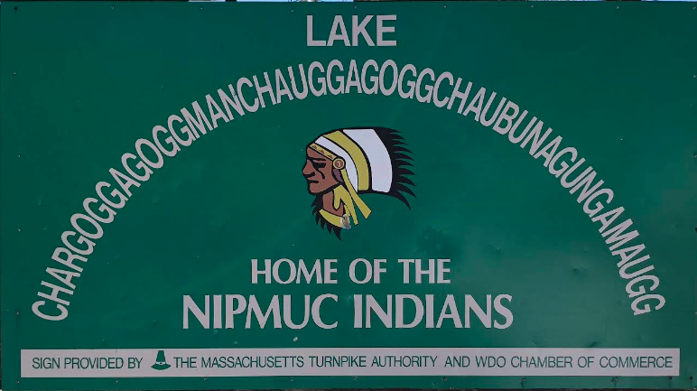
4) The second longest place name in the world (in Wales) is:
Llanfairpwllgwyngyllgogerychwyrndrobwllllantysiliogogogoch (58 letters).
The name means “Parish church of St. Mary in the hollow of the town of White Hazel near the rapid whirlpool and the parish church of St. Tysilio with a red cave”.
Pronunciation: https://www.youtube.com/watch?v=fHxO0UdpoxM (short)
https://www.youtube.com/watch?v=bCw2AtN430M (1 min)

5) The third longest place name in the world is a lake in the US state of Massachusetts:

Lake Chargoggagoggmanchauggagoggchaubunagungamaugg (45 letters)

Chemical names, which can be very, very, very long, are generally not included in dictionaries. The longest recorded one has 189,819 letters, and is the name of the largest known protein, “Titin” (https://en.wikipedia.org/wiki/Titin). Its name is sometimes said to be the longest word in the English language, or of any language. However, lexicographers regard chemical compound names as “verbal formulae”, and not words. To say the full name, at a rate of 270 syllables per minute (the average speaking speed for normal conversation), would take about 6 hours (without stopping).

Long words in Portuguese

1) Pneumonoultramicroscopicsilicovolcanoconiosis (45 letters)
See #6 on Page 1.

2) Pneumoultramicroscopicossilicovulcanoconióticos (47 letters)
This is an adjective referring to carriers of the disease described in #1.

3) Anticonstitucionalissimamente (29 letters)
This word is recognized as being the longest non-technical word. It means “very unconstitutionally”.

